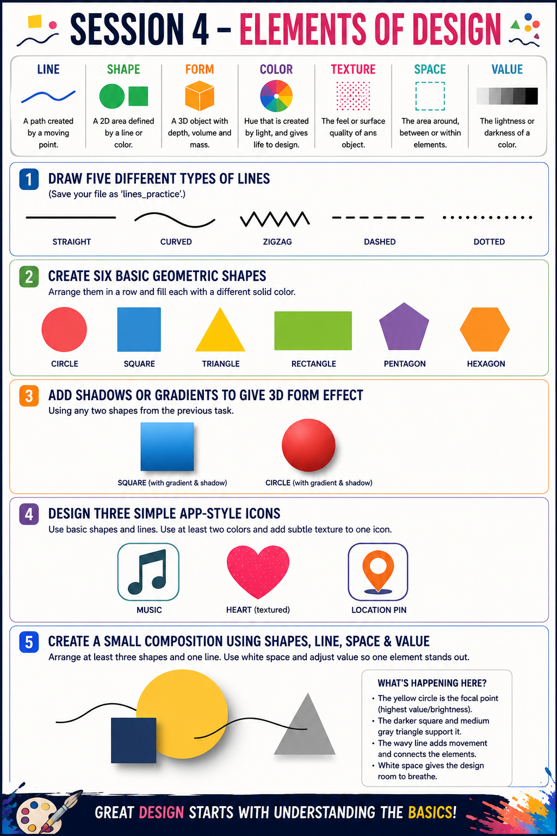SESSION 4 – Elements of Design Explanation
1. Line
Five different types of lines were created:
- Straight Line – shows stability and direction.
- Curved Line – creates smooth movement and flow.
- Zigzag Line – gives energy and excitement.
- Dashed Line – suggests separation or pathways.
- Dotted Line – creates a soft visual guide.
These lines demonstrate how different line styles communicate different feelings.

2. Shape
Six geometric shapes were created and filled with different colors:
- Circle
- Square
- Triangle
- Rectangle
- Pentagon
- Hexagon
Shapes are basic building blocks of design and help organize visual information.

3. Form
The circle and square were enhanced using gradients and shadows.
- Shadows create depth.
- Gradients add light and dimension.
- The shapes appear more realistic and three-dimensional.
This demonstrates the design element called Form.

4. Color & Texture
Three app-style icons were created:
🎵 Music Icon
❤️ Heart Icon
📍 Location Pin Icon
- Multiple colors were used to make the icons attractive.
- A subtle texture was added to the heart icon.
- Color helps attract attention, while texture adds visual interest.

5. Space & Value
A composition was created using:
- Three shapes
- One curved line
- Intentional white space
Value (Lightness and Darkness):
- The bright yellow circle has the highest value and becomes the focal point.
- The darker square and medium gray triangle provide contrast.
- The curved line connects all elements and adds movement.
Space:
- Empty space around the objects prevents clutter.
- White space improves balance and readability.

Conclusion
This session demonstrates the seven Elements of Design:
- Line creates direction and movement.
- Shape forms the foundation of visual design.
- Form adds depth and realism.
- Color creates emotion and emphasis.
- Texture adds visual interest.
- Space improves organization and clarity.
- Value creates contrast and focal points.

